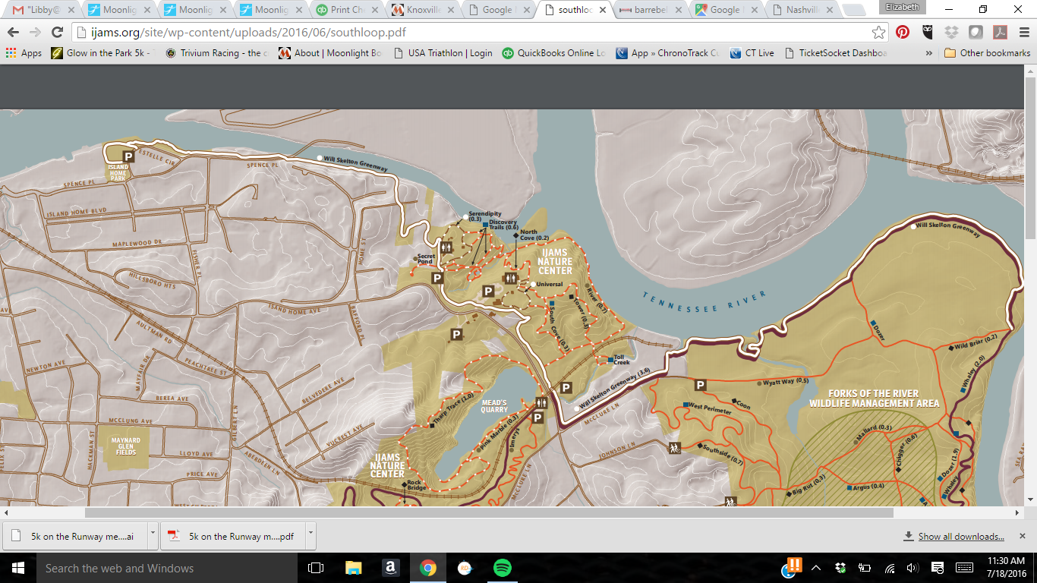

Start/Finish Line

Event Parking